Information Technology Solutions Plan

Ivan Novasak

Southern New Hampshire University

IT 515: Innovation in Information Technology

Dr. William McConnell

2024 July 14

# Information Technology Solutions Plan

**Background**

The purpose of this document is to define HYPERVSN’s needs and explore three technologies for developing a “fully immersive holographic suite” that allows retailers’ customers to touch, see, and move objects within the hologram without having to wear any special equipment on their person (McConnell, 2024). The product’s requirements are as follows (McConnell, 2024):

* 200 square feet (18.6 m2) area with 6 holographic walls.
* Customers should be able to interact with the holographic image by being able to touch and feel it - including the material the displayed product is made out of.
* Customers need to be able to talk to the system to change items like they already do with their phones for voice command.
* Additional movements need to be able to be performed via touching.

HYPERVSN has three development locations at London, Vilnius, and Minsk, while another company they are working with for the project, Euclideon Holographics, is in Brisbane, Australia (McConnell, 2024). The desired launch date HYPERVSN is by 2029 and the budget is $2,500,000.

# Needs and Challenges

According to William McConnell, the primary challenge both HYPERVSN and Euclideon are facing is they do not have truly immersive technology - they can do holograms alone but not including the ability for a person to touch the holographic objects just as they would physical real-world objects (McConnell, 2024). There also appears to be nothing noted about either HYPERVSN or Euclideon regarding any voice command experience in the summary document (McConnell, 2024). A potential way to address the touch challenge is using a technology that is being pioneered by Ravinder Dahiya, a professor of electronics and nanoengineering, and his other colleagues at the University of Glasgow (Dahiya, 2021). This technology is known as aerohaptics, and it works by a system puffing carefully directed jets of air to people’s hands and wrists to create the sensation like real touching (Dahiya, 2021).

**Research and Critique**

The next section of this document is for researching and critiquing three technologies that could be used for the holographic product.

**Three Innovative Technologies**

***University of Glasgow’s Aerohaptics***

Developed by Ravinder Dahiya, the aerohaptics technology does not require the user to wear gloves or any other equipment to experience the sensation on their hands (Dahiya, 2021). To display the hologram objects, glass and mirrors are used, with the mirrors being arranged in a pyramid shape with one side left open for the user to put their hands in to feel the holographic object (Dahiya, 2021). A sensor is located below the mirror pyramid that tracks the hands and fingers of the user, so the air jet nozzle can stay directed towards the user’s hands (Dahiya, 2021). The nozzle can even adjust for when the user moves their hands around via changing the combination of force and air quantity (Dahiya, 2021). Aerohaptics has successfully been used to simulate the sensation of a basketball - allowing the user to touch, roll, bounce, and push the ball with varying forces and experience the different sensations like they would a real ball (Dahiya, 2021). Dahiya hopes to be able to add other senses, like smell, as well as the ability to change the temperature of the directed air flows to create even more realistic experiences (Dahiya, 2021). The main software behind the image generations and tracking of the user’s hands is the Unity Game Engine, which is a product already used in the videogame industry (Dahiya, 2021). The programming language used for the algorithm is C# and the hardware used to control motion sensing is the Arduino and Leap Motion sensor (Christou et al., 2022).

The cost for generating the basketball hologram experiment was approximately $700 USD (Christou et al, 2022). The aerohaptics technology can be useful as it provides the ability for the user to touch a virtual object - something that in the past could only be seen.

**Virtual On’s Virtual Fashion Mirror**

Virtual On, Ltd. has created a holographic product for clothing retailers called the Virtual Fashion Mirror that allows customers to overlay an image of clothing they would like to try onto their own body image in the correct size and shape as well as the desired colors (Virtual On, 2024a). This product uses 3D imaging augmented reality (AR) technology and smart mirrors to automatically gauge the person’s body size and shape in seconds and allows the customer to move around and see how the clothing will move with their body in tandem (Virtual On, 2024a). The customer can switch virtual clothing articles using gestures or a tablet, though the tablet is not necessary (Virtual On, 2024a). The customer can even try multiple virtual items on simultaneously so they can create an entire outfit virtually and see how it will look on them (Virtual On, 2024a). The product can record and take pictures the customer can download and share on social media via scanning a QR code with their phone if they wish (Virtual On, 2024a). The experience can also be tied into promotions and the customer can get a print-out of themselves with the virtual outfit on (Virtual On, 2024a). Retailers and boutiques can use their own 3D clothing designs or allow Virtual On to create some of their own for retailers to use (Virtual On, 2024a). The main advantage of the Virtual Fashion Mirror for retailers is cost savings in both needed floor space and inventory stock by not needing to carry all color and style variations of a given clothing product on site (Virtual On, 2024a). For customers, the advantage is they can see how they look in real time not just in photos but a video of themselves moving in the virtual clothing prior to deciding whether to buy the items (Virtual On, 2024a). The Virtual Fashion Mirror has a simple setup procedure that retailers can use that is Plug and Play using a “USB memory containing the desired video file or interactive software” (Virtual On, 2024a). According to Virtual On’s factsheet on the Virtual Fashion Mirror, one LCD screen measures 94 by 193 cm or 37 by 76 inches including the stand and the installation footprint has a minimum volume of 1.5 m / 4.9 ft width, 2 m / 6.5 ft height, and 1.5–2.5 m / 5–8.2 ft depth (Virtual On, n.d.). If the maximum values are assumed, this would yield in a minimum room size of (40.4 ft2) assuming just one Virtual Fashion Mirror unit. The all-in-one model includes the following components (Virtual On, n.d.):

* Processors
* Kinect Camera
* WiFi Router
* Virtual Fitting Application
* Cloth Authoring Tool

The Virtual Fashion Mirror can be purchased for 18,000 USD/EUR or 15,000 GBP or rented for 12,000 USD/EUR or 10,000 GBP (Virtual On, 2024a). The choice of whether to rent or buy depends on the needs of the customers. A shop with a continuous presence would save money by buying, whereas a shop that only needs the unit temporarily could see renting it (Virtual On, 2024b).

Virtual On, Ltd. can be reached by phone on +44 2 030 340 049 in the UK and +1 385 249 5233 and +1 917 475 0219, or by email at [info@virtualongroup.com](mailto:info@virtualongroup.com) (Virtual On, 2024b).

**3DLOOK’s Mobile Tailor**

3DLOOK is another company who does custom imaging for clothing retailers. All that is needed are two photos 3DLOOK’s app takes from the user’s smartphone, a front, and a side shot, for a 3D digital body model to be created from 86 measurements the software extracts (3DLOOK, 2024a). The photos are processed to make a 3D model with accurate measurements and user preferences on whether they want their clothing to fit tighter or looser (3DLOOK, 2024a). 3DLOOK gets size and fit recommendations via algorithms that take specific manufacturers, the season, type of clothing, and fit intent to get an optimal size recommendation for the customer (3DLOOK, 2024a). The next step is the virtual try-on, which is another area where the customer will interact. This is where the customer will be able to see in the app on their phone how the clothing will look on them in a full 360° representation of their body (3DLOOK, 2024a). 3DLOOK says it uses “3D body mesh enhancements and body tracking” and “[A] new cloth simulation machine learning algorithm recreates the texture of fabrics. The semantic generation module modifies the person’s segmentation map to identify the area on the body that should be covered with the target clothes and warps the clothing mask accordingly” (3DLOOK, 2024a).

The advantages of 3DLOOK’s Mobile Tailor are the customer can see how they will look in the new clothes, cutting down on ruler measurements, no need for a large room or other specialized equipment to use this product, end-to-end SSL encryption of all photos in compliance with GDPR, and the ability for customers to measure from home in the app prior to coming into the boutique (3DLOOK, 2024a/c). Some examples of businesses who will benefit include (3DLOOK, 2024c):

* Luxury made-to-measure brands.
* Ready-to-wear businesses.
* Custom apparel companies.
* On-demand manufacturing.
* Bridal and tuxedo businesses.
* Uniform manufacturers.

Some of these companies who use our service include Gorski Montréal, Baynes + Baker, Lanieri Italia, Redthread, Tailoor, The Modern Groom, Les Aimants New York, The Scrub life, and Lakeland (3DLOOK, 2024c). Advantages for businesses include up to 20% decrease in returns, expansion beyond the local area/entry into new markets, personalized and enhancement of the customer experience, and up to a 90% reduction of remakes (3DLOOK, 2024c).

Pricing is on a subscription basis with 3 monthly or yearly options with a 7-day free trial available to test drive the service (3DLOOK, 2024b). The Basic option costs $499/month or $5,389/year and includes (3DLOOK, 2024b):

* Up to 100 scans per month.
* 80+ measurements.
* 3D Model View & Export.
* Web Widget Integration.
* Basic Support.

The Premium option costs $999/month or $9,590/year and includes the following in addition to what the Basic option has (3DLOOK, 2024b):

* Up to 500 scans per month.
* Widget Customization.
* Real-Time Notifications.
* SMS/E-Mail Web Templates.
* Premium Support.

A third option, Enterprise requires talking to the sales department for pricing, and includes, in addition to the Basic and Premium options (3DLOOK, 2024b):

* Over 500 scans per month.
* API.
* Dedicated Support.

**Assessment**

***Costs***

For the University of Glasgow’s aerohaptics, the cost was referenced at $700 for reproducing the basketball-shaped object (Christou et al., 2022), though no other costs were mentioned and it is not clear how much more it would cost to scale it up to larger sizes, such as full clothing articles. There is no large screen/wall or voice command support, so this technology will need to be combined with another at further cost anyway.

For Virtual On’s Virtual Fashion Mirror, the purchase price for one unit was 18,000 USD/EUR and rental was 12,000 USD/EUR (Virtual On, 2024a). Since the requirements by McConnell (2024) indicate the need for six walls, the price to buy six Virtual Fashion mirrors to lay out in that orientation will be USD/EUR and to rent six units will cost USD/EUR.

3DLOOK’s Mobile Tailor product runs on a different pricing model when compared with Virtual On’s and the University of Glasgow’s options in that an ongoing subscription is required. They charge less for an annual subscription, but there is no public disclosure for the Enterprise option. If an assumption is made that it will cost twice what the Premium option is, based on the ratio between Premium and Basic, one arrives at Mobile Tailor costing USD per year for each company who wants to go with this technology. As this product only includes a smartphone app and subscription, additional funds will be needed for any existing holographic equipment. Since this product already uses a smartphone, voice command could be utilized within the smartphone’s existing feature set and accessibility settings (Google, n.d.).

**Implementation**

To implement the aerohaptics technology from the University of Glasgow, they require following hardware (Christou et al., 2022):

* pseudoholographic display.
* gesture recognition module.
* haptic feedback device.
* PC.
* Tablet.
* Arduino board.
* USB cable.
* Leap Motion sensor.

Figures 1–3 show how the system is set up and how it functions graphically (Christou et al., 2022).

**Figure 1**

Left (a): Block diagram of hardware and software setup.

Right (b): 3D diagram of devices, table they are set on, virtual ball object, and a person’s hand reaching to touch it.

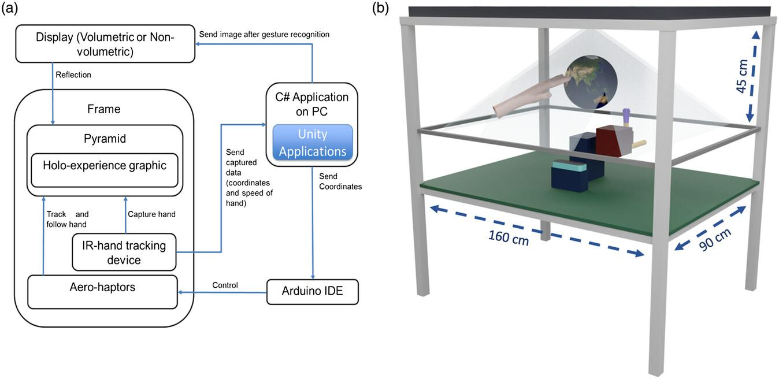

*NOTE*: Image is Copyright Christou, A., Chirila, R., and Dahiya, R. (2022).

**Figure 2**

Left (a): Close-up illustration of a person’s hand reaching into a transparent pyramid structure touching the virtual ball as it is sat onto a platform, nozzle blowing a puff of air at the object.

Right Top (b): Side view illustration of the hand tracking device, air nozzle, air supply, and rotation directions.

Right Bottom (c): 3D coordinate positions of finger, center points, and servo rotations with X/Y/Z offsets.

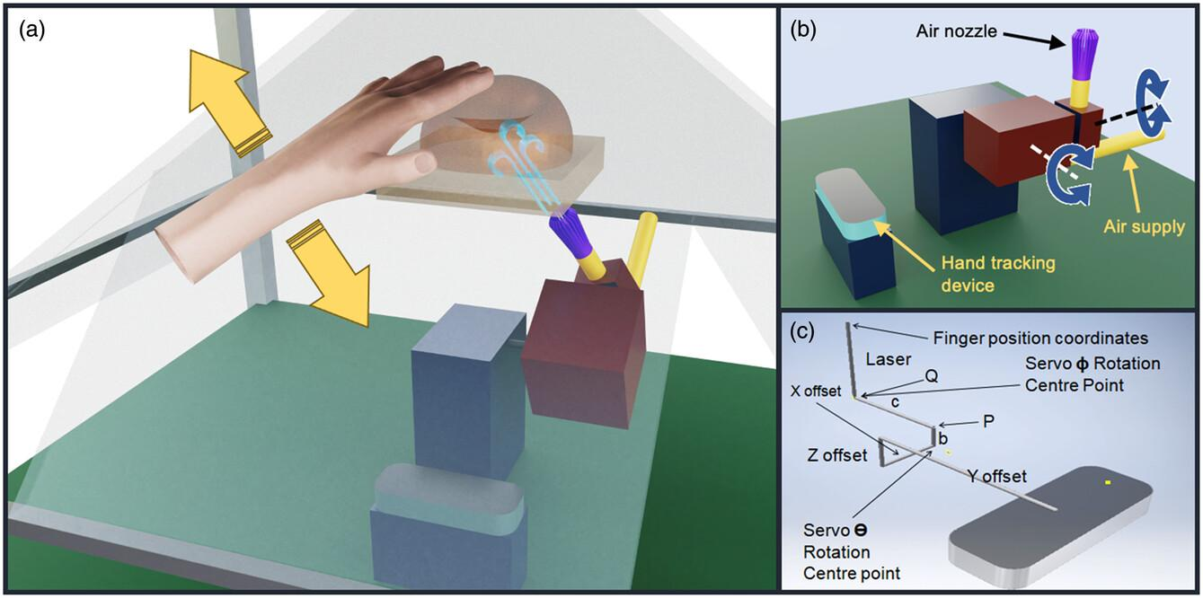

*NOTE*: Image is Copyright Christou, A., Chirila, R., and Dahiya, R. (2022).

**Figure 3**

Top (a–e): Pictures of hand and finger tracking via Leap Motion sensor.

Left Bottom (f/g): Picture showing user’s hand dribbling virtual basketball slowly and quickly.

Right Bottom (h): Graph showing the air force in Newtons vs. elapsed time in seconds.

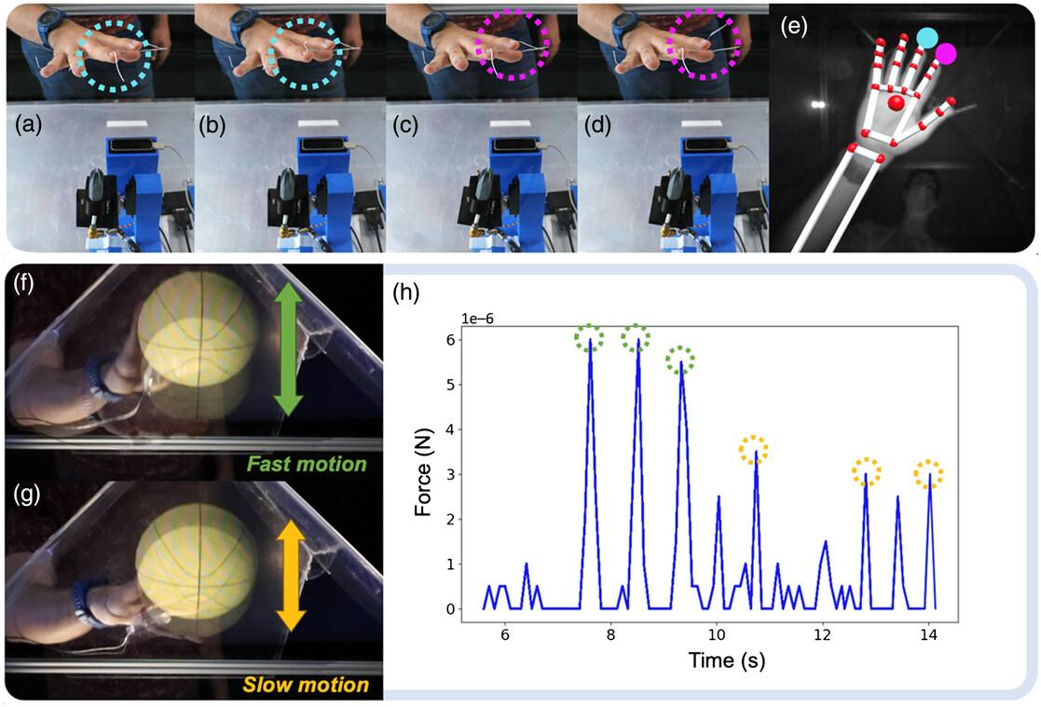

*NOTE*: Image is Copyright Christou, A., Chirila, R., and Dahiya, R. (2022).

Implementing Virtual On’s Virtual Fashion Mirror requires purchasing of the following hardware components (sold together):

* Processor.
* Kinect Camera.
* WiFi Router.
* Fashion Mirror (LCD Screen).
* Stand for the screen.

The following software are included with purchase of the all-in-one unit:

* Virtual Fitting Application.
* Cloth Authoring Tool.

Implementing this system is as follows: Figure 4 shows a diagram of the system from the rear of the room facing towards the person and the Virtual Fashion Mirror at a ¾ angle (Virtual On, n.d.). Figure 5 shows a similar diagram but from the side, with dimensions of the floor’s length and height of the Virtual Fashion Mirror’s full footprint (Virtual On, n.d.). Figure 6 shows a similar diagram from above, including a measurement of the floor’s width (Virtual On, n.d.).

**Figure 4**

View from rear at ¾ angle, showing the floor, stand, Virtual Fashion Mirror, camera, and silhouette of person.

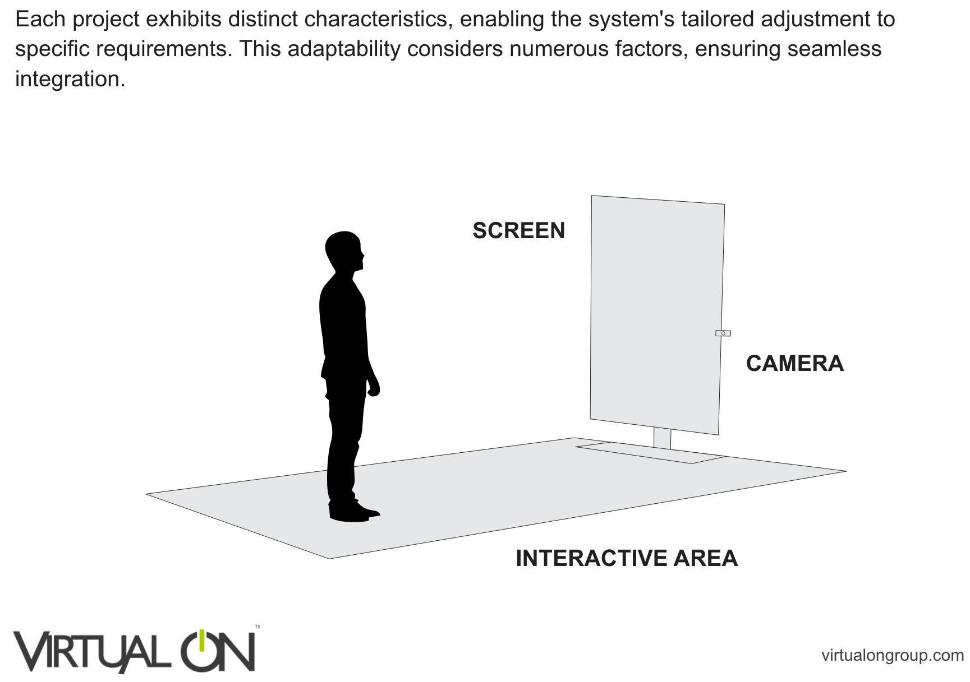

*NOTE*: Image (Virtual On, n.d.) is Copyright VIRTUAL ON LTD.

**Figure 5**

Side view showing the floor, stand, Virtual Fashion Mirror, camera, silhouette, and dimensions for the floor length and system’s height.

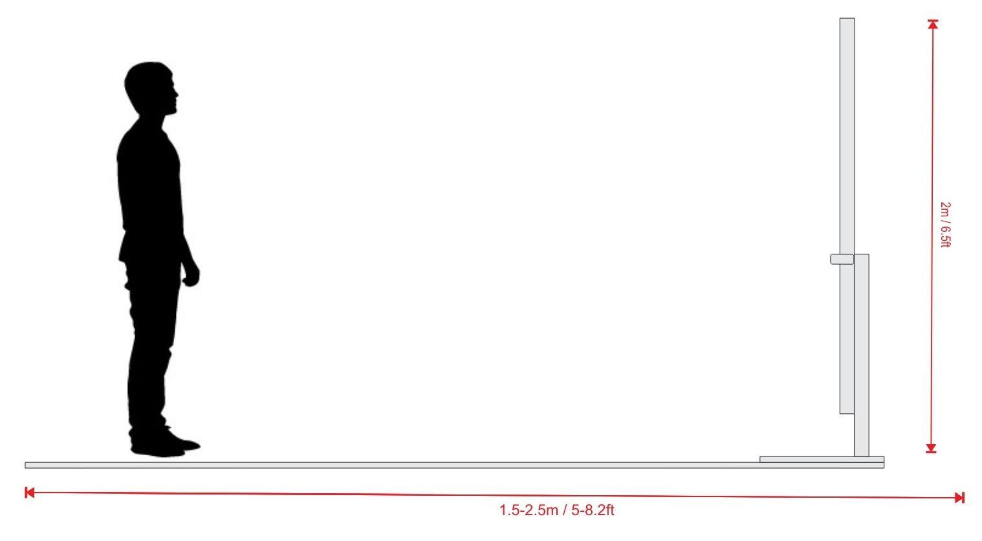

*NOTE*: Image (Virtual On, n.d.) is Copyright VIRTUAL ON LTD.

**Figure 6**

View from above, showing the floor, Virtual Fashion Mirror, stand, silhouette of a person, and measurement of the floor width.

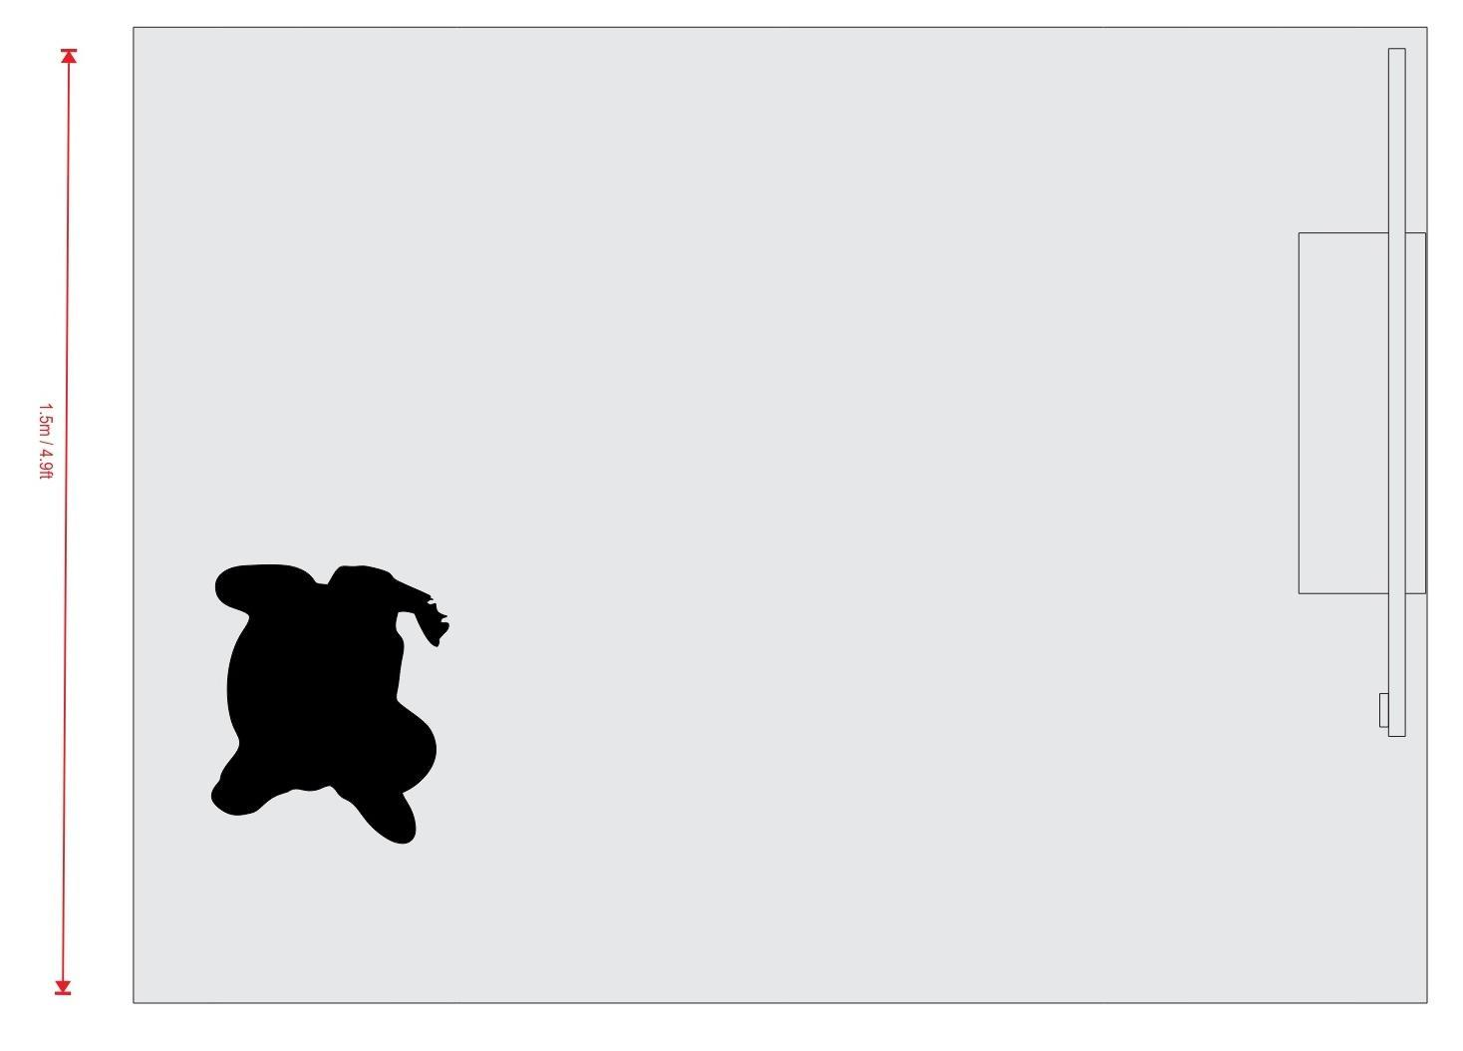

*NOTE*: Image (Virtual On, n.d.) is Copyright VIRTUAL ON LTD.

Figure 7 shows a screenshot from Virtual On’s website with the Virtual Fashion Mirror in action in a variety of scenarios (Virtual On, 2024a).

**Figure 7**

Sample renderings of the Virtual Fashion Mirror in use.

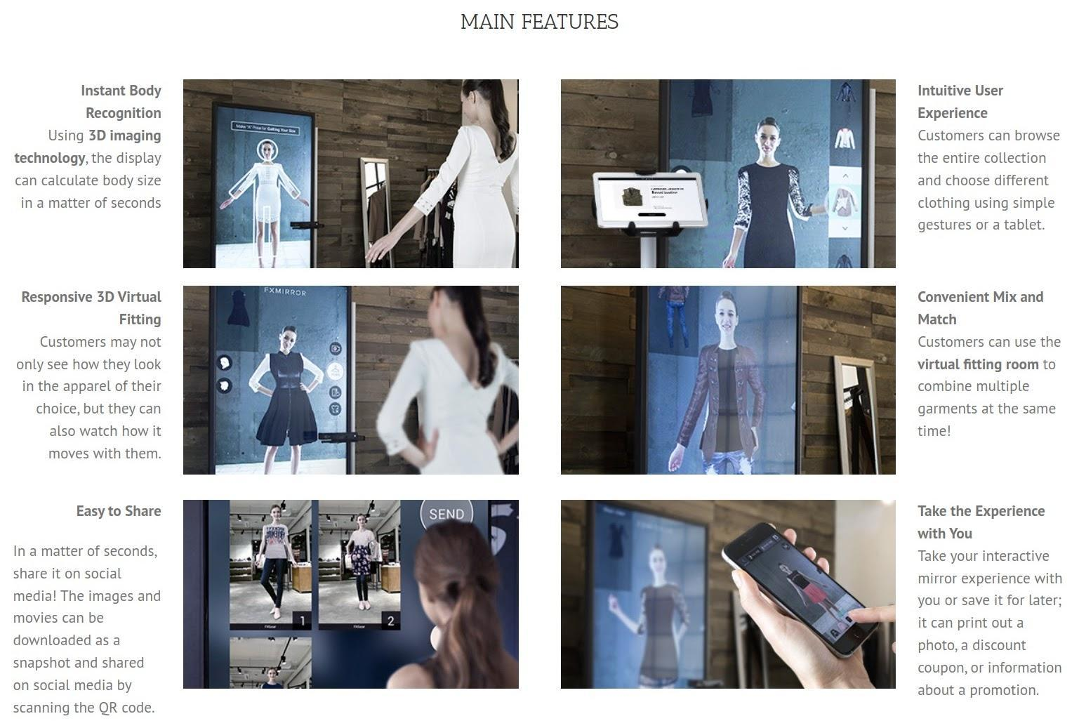

*NOTE*: Images and text (Virtual On, 2024a) in this figure are Copyright VIRTUAL ON LTD.

Regarding setup, Virtual On says the Virtual Fashion Mirror “operates on a Plug and Play basis,” which signifies that it does not necessitate any complex setup procedures. All one needs to do is insert a USB memory containing the desired video file or interactive software. This user-friendly approach eliminates the need for extensive configurations or technical expertise, making the process straightforward and accessible for users (Virtual On, 2024a).

Implementation of the 3DLOOK Mobile Tailor can be done in three ways depending on the type of retailer: online retailers, brick-and-mortar shops, or independent vendors (3DLOOK, 2024c). For online retailers, they would integrate 3DLOOK’s “Get Measured” via the API into their website (3DLOOK, 2024c). Brick-and-mortar shops would use 3DLOOK’s “Scan a customer” feature to generate a QR code the customer can scan with their phone to take the two pictures that will be sent into 3DLOOK’s model (3DLOOK, 2024c). Independent vendors can use 3DLOOK’s administration panel to send a custom email or text message to their customers so they can take their photos in a similar way as is done with the QR code (3DLOOK, 2024c). Figures 8–12 show the process of getting a 3DLOOK body scan via online retailer RedThread. A similar scanning process happens with the other methods via QR code or email/text link sent by brick-and-mortar and independent vendors. The user first goes to <<https://redthreadcollection.com/>> in their web browser, clicks the Scanning Studio link, clicks the “Try A Scan Now” button, enters their name, e-mail address, and phone number into a short form, then clicks the “Next” button (RedThread, n.d.). Next, the user will be sent a link on their phone to click, where their web browser will open to the retailer’s scanning web page, then ask the user to accept the use of the camera (RedThread, n.d.). Then, the user will be told to stand three to four steps back to automatically snap their two photos (front and side), or have a friend do the same (this step is omitted from the figures in this document for privacy) (RedThread, n.d.). Afterward, the user can buy their custom-fitting clothing in the shopping basket (RedThread, n.d.).

**Figure 8**

Screenshot of an Android phone showing a link for the user to connect to RedThread’s scanning studio.



**Figure 9**

Prompt for the user to enter their height (a similar one for their weight comes up next).



*NOTE*: Contents of the image are Copyright RedThread.

**Figure 10**

The scanning studio is ready to take the two photos. A privacy notice is displayed; they will be deleted right after they are processed. The user is prompted for if they will take the pictures alone or have someone else take them.

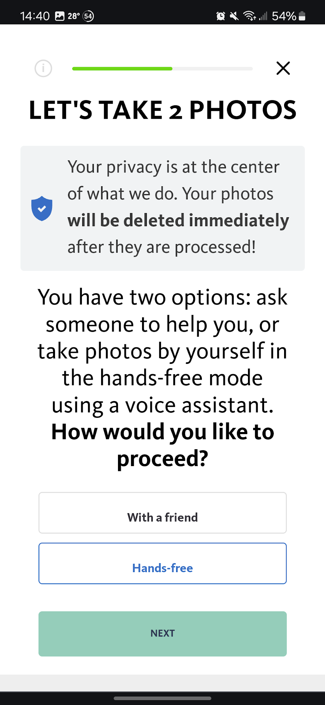

*NOTE*: Contents of the image are Copyright RedThread.

**Figure 11**

The photos have been snapped; they are being processed.

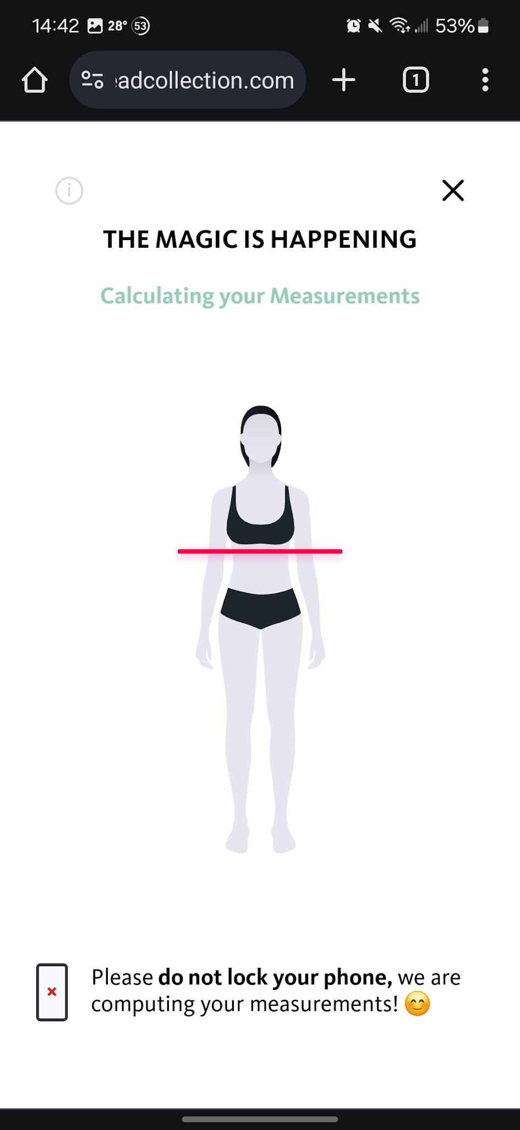

*NOTE*: Contents of the image are Copyright RedThread.

**Figure 12**

The user is told the scan was a success, and they may proceed to buy the product.



*NOTE*: Contents of the image are Copyright RedThread.

***Who Benefits?***

With the University of Glasgow’s aerohaptics technology, the prominent people who will benefit from this technology are customers who come into retail shops and want to feel what an item feels like that is not present at the shop. Retailers will benefit, too, as they will allow the person to both see and feel a product that is not yet in stock and can allow them to keep shops smaller by not needing as much inventory. Customers can see the hologram, feel the virtual clothing, and decide whether to buy it at that instant, no matter if the store has it.

For Virtual On’s Virtual Fashion Mirror, more entities can benefit: customers, retailers, environmentalists, and manufacturers. With the ability for customers to see how an article of clothing looks on their body at the shop, they can have more information on how the clothing will fit their style. Like with the aerohaptics, stores need not carry as much inventory as customers can try on clothing virtually, and instead, the retail could ship them the actual clothing once they buy it. Environmentalists and manufacturers can benefit through less landfill waste and money savings on clothing that is tried on and returned due to a bad fit.

3DLOOK’s Mobile Tailor technology has its own set of benefits, too. It can be used by not only brick-and-mortar retailers but online ones, too. Customers, retailers, and manufacturers are the primary beneficiaries. Customers can be ensured they will have the right fit and a personalized experience whether they are buying online or offline. So, there is less inconvenience over exchanges due to poorly fitting clothing. Another benefit customers have is privacy in that their photo is encrypted and deleted after processing, and less worry over the sanitation of retail fitting rooms as the 3DLOOK modeling software ensures an accurate fit. Retailers benefit by up to 20% less returns and up to 90% less waste on remakes. Manufacturers benefit significantly from 90% fewer remakes as their fabrics will be more efficiently used.

***Affected Stakeholders***

For all three technologies, customers, retailers, and component manufacturers are three stakeholders, as they will be the users exposed to the daily usage and manufacture of the technology.

For the aerohaptics technology, there is the addition of the University of Glasgow, who developed this technology and will need to be contacted to further refine their product for clothing and retail boutique usage.

For Virtual On’s Virtual Fashion Mirror, a different stakeholder will be Virtual On themselves as developer and supplier of the product. Another stakeholder will be clothing designers and manufacturers, as they will be impacted positively by having more sales.

For 3DLOOK, they are a stakeholder as provider of the technology, also there are the clothing manufacturers and designers as with Virtual On, also the telecommunications providers are an additional stakeholder for sending the text message or e-mail link to the customer.

***Implementation Support***

The people to contact for both installation/initial purchase as well as after-sales support will vary on which technology(ies) are chosen. For the aerohaptics technology from the University of Glasgow, Ravinder Dahiya is the correspondence person, and they may be reached via email at Ravinder.Dahiya@glasgow.ac.UK (Christou et al., 2022).

For the Virtual Fashion Mirror, Virtual On’s complete contact information is as follows (Virtual On, 2024a):

VIRTUAL ON LTD

UK: +44 2030 340 049

US: +1 385 249 5233 or +1 917 475 0219

Spain: +34 910 603 515

Showroom location:

Moulton Park Business Centre, Office G10A, Red House Road, NN3 6AQ Northampton, UK

Email: [info@virtualongroup.com](mailto:info@virtualongroup.com)

Web: <<https://virtualongroup.com>>

Virtual On also has a social media presence for people who prefer to connect that way:

* Facebook: <<https://www.facebook.com/virtualongroup/>>.
* X (formerly known as Twitter): <<https://twitter.com/Virtualongroup>>.
* YouTube: <<https://www.youtube.com/c/VirtualON>>.
* Instagram: <<https://www.instagram.com/virtualongroup/>>.
* LinkedIn: <<https://www.linkedin.com/company/5060325/>>.
* Pinterest: <<https://www.pinterest.co.uk/virtualoncouk/>>.

3DLOOK has a web form located at <<https://3dlook.ai/contact-us/>> as well as the following social media links:

* Facebook: <<https://www.facebook.com/3DLOOK.me/>>.
* Instagram: <<https://www.instagram.com/3dlook.ai/>>.
* X: <<https://twitter.com/3dlook_me>>.
* LinkedIn: <<https://www.linkedin.com/company/17878391/>>.
* YouTube: <<https://www.youtube.com/channel/UCPQIzvlU_Ht0b1g1oV7s3gQ>>.

***Which solution is the most cost-effective?***

Table 1 shows the costs of each technology mentioned in the Assessment - Costs section of this document, assuming the most premium options and purchase as opposed to renting, where possible.

**Table 1**

*Costs of each technology.*

|  |  |  |  |  |
| --- | --- | --- | --- | --- |
| **Technology** | **Initial Cost** | **Ongoing Costs** | **Accessory Costs** | **Total Costs** |
| **Aerohaptics** | $700 | <Unspecified> | PC: $733 (Statista, 2024) | $1,433 |
| **Virtual Fashion Mirror** | $108,000 (6 units) | None - product is owned | Smartphone: $823 (Statista, 2023) | $108,823 |
| **3DLOOK Mobile Tailor** | $0 (7-day free trial);).  $1998 (first month) | $1,998/month or $19,180/year | Smartphone: $823 | $4,819 (first 60 days) |

The cheapest option may not always be the best way to go. Whatever option suits the needs of the stakeholders will be used. Any (or even all) of these options, plus other unforeseen costs that may come up during the project, will easily fit into the HYPERVSN budget of $2,500,000.

**Selection**

## A combination of two technologies listed in this document will need to be used to cover all the project’s requirements: the aerohaptics and Virtual On’s Virtual Fashion Mirror. The Virtual Fashion Mirror (several for a whole room) will display the holograms via the mirror, move them via cameras that see the user, and an app on a tablet or smartphone for dictation and sending the user their designs. The aerohaptics will allow users to touch the virtual fabrics they see on the screen. The 3DLOOK Mobile Tailor technology could also be incorporated later should a retailer want to offer custom-tailored clothing online. Virtual On’s and 3DLOOK’s technologies have the advantages of existing commercially. In contrast, the University of Glasgow’s aerohaptics technology is experimental with no mention of how it could be scaled up to a larger size beyond a basketball as would need to be the case for a person wearing virtual clothing. So, a hybrid approach looks ideal.

**Adoption and Strategies Proposal**

The next section of this document is to show which technological phases the University of Glasgow’s aerohaptics and Virtual On’s Virtual Fashion Mirror technologies are in, describing the ideal time customers would be interested in the hybrid aerohaptics/Fashion Mirror product, the adoption timelines, and any variables that may affect launching the technology.

# Technology Life Cycle Phases and Stages

According to Hitesh Bhasin of Marketing91, there are four phases in the technology life cycle (Bhasin, 2019):

1. Research and Development (R&D). This phase is first and is where technology is being developed, and much money is spent trying to make it viable (Bhasin, 2019). The developers will often use their own money to fund the development at this stage and the failure rate is high for technologies at this stage (Bhasin, 2019). This is the phase where technology would be considered experimental and not yet commercialized. Companies with technologies in this phase need to get feedback from industry experts to ensure successful commercialization (Bhasin, 2019).
2. Ascent. This second phase is where technology has gotten some acceptance in the market and is making at least some profits for the company (Bhasin, 2019). This is the stage where a new product is being hyped to grab the attention of industry insiders and consumers (Bhasin, 2019).
3. Maturity. The third phase is when a technology has reached a critical mass of consumers, and the company is making good, stable profits from it (Bhasin, 2019). It is where technology is transitioning into commoditization, and the market is becoming saturated, with many customers already owning the product (Bhasin, 2019). This is also the phase where more competitors try hard to steal the innovator’s thunder and launch their product versions with their changes incorporated (Bhasin, 2019). Revenues in this phase begin to fall as most customers who wanted the product already have one, so fewer new customers exist as time marches on (Bhasin, 2019). Companies with technologies in this phase need to pay attention to the market and future wishes of consumers to try to make incremental improvements in the originally invented technology (Bhasin, 2019).
4. Decline. This final phase of the technology life cycle is where a technology generates fewer or no profits and is being replaced in the market by customers with a newer innovation that better serves their needs (Bhasin, 2019). Profits are either low or negative in this phase, so it is best for companies with technologies in this phase to move into developing a different technology that is in an earlier phase, where high profits are possible (Bhasin, 2019).

These four phases are accompanied by four stages of technology development that roughly line up with the four phases:

1. Innovation. This first stage is where a product’s R&D has been completed, and the product can be pilot tested in the market, where uptake will be judged, and the company will later decide whether to increase production based on the results (Bhasin, 2019).
2. Syndication. This second stage is where a product is heavily focused on, and other projects are deprioritized in the company to focus on this new technology that is selling very well in the marketplace and becoming popular with consumers (Bhasin, 2019).
3. Diffusion. This third stage is where a technology or product has become a winner for the industry and consumers (Bhasin, 2019). Consumers’ trust in the brand or company is high, and in this stage, the company focuses on how many consumers they can win over in the market (Bhasin, 2019). Profits are maximized in this phase as the product captures both the earlier consumers and the ones who waited longer to adopt the technology (Bhasin, 2019).
4. Substitution. This final stage is where the company focuses on a new technology to replace the existing one in their target markets (Bhasin, 2019). How long this stage lasts depends on market dynamics and technical or non-technical factors that govern how soon a replacement is needed (Bhasin, 2019).

## *Which phase is each technology in?*

According to Adamos Christou, Radu Chirila, and Ravinder Dahiya at the University of Glasgow, the aerohaptics technology is still being worked on and was presented as a proof-of-concept for feeling a hologram that is the size of a basketball (Christou et al., 2022). This would indicate that aerohaptics is in the R&D phase and not yet at the innovation stage, so it has not yet been commercialized, nor is it ready for pilot testing.

Virtual On’s Virtual Fashion Mirror is a finished product that sells for 18,000 USD/EUR / 15,000 GBP or could be rented for 12,000 USD/EUR / 10,000 GBP (Virtual On, 2024). According to Dimension Market Research (DMR), the virtual mirror market “is estimated to have a value of USD 10.0 billion in 2023 and is expected to reach USD 72.4 billion by the end of 2032” (DMR, 2023). Virtual On has several competitors, including Cisco, ViuBox, SenseMi, and Terawe Corp (DMR, 2023). In April 2023, Snap, makers of the popular social media platform *Snapchat*, planned to install virtual mirrors in some US Nike stores and a Men’s Wearhouse in Paramus, New Jersey (DMR, 2023). This technology is at least in the ascent phase or the innovation or syndication stages.

So far, no one has yet combined these two technologies, which is where HYPERVSN can have an edge over the other virtual/AR mirror manufacturers on the market by combining the University of Glasgow’s aerohaptics with Virtual On’s Virtual Fashion Mirror.

***Ideal Adoption Time***

According to DMR, the virtual mirror market is forecast to have a 24.6% cumulative annual growth rate from 2023 to 2032. Armed with this information, as well as the raw market value estimates from 2023 and projection to 2032 and HYPERVSN’s goal of launching by 2029 (McConnell, 2024), it appears that the late 2020s (circa 2027) will be an ideal adoption time because the market will have had several years of exposure to virtual mirrors by various competitors and consumers will be ready for the next innovation. By this time, the aerohaptics may have matured more and be ready to be commercialized.

**Timeline**

According to OnDigitalMarketing, there exist five groups of customers that take on different timelines for adopting a new technology (OnDigitalMarketing, 2023):

1. Innovators, the earliest group, consisting of 2.5% of adopters, are the youngest consumers, most willing to take risks on a new, unproven product, are of the highest social classes, and have the highest disposable income, which can weather a product failure (OnDigitalMarketing, 2023).
2. Early adopters, at 13.5%, are the second group (OnDigitalMarketing, 2023). They do not buy into a product as fast as the innovators and may wait until there are signs it will succeed before investing in it (OnDigitalMarketing, 2023). This group is still young, has high social standing, has a high disposable income, and has advanced education (OnDigitalMarketing, 2023). This group may have a significant influence over the rest of the market that can indicate if the new product will hit critical mass amongst consumers (OnDigitalMarketing, 2023).
3. The early majority, at 34%, is the third group of technological adopters (OnDigitalMarketing, 2023). This group generally waits until a product has succeeded and the early adopters have reported on their experiences (OnDigitalMarketing, 2023). They do not have the highest social status but still have above-average social status (OnDigitalMarketing, 2023). These first three groups cover half of the adopters of a technology or new product (OnDigitalMarketing, 2023).
4. The latter majority, with 34% of consumers again, represents the first of two groups more skeptical about adopting new technology (OnDigitalMarketing, 2023). They wait until the average consumer has already been using it before deciding to incorporate it into their life (OnDigitalMarketing, 2023). Their social status is lower than average, and their incomes are lower than average (OnDigitalMarketing, 2023).
5. Laggards, 16%, are the final group of technological adoptees (OnDigitalMarketing, 2023). This group is typically older and the most risk-averse to adopting new things, including technologies (OnDigitalMarketing, 2023). This group typically has a small social circle consisting of only family and close friends and typically will not buy into a new idea until society forces it on them (OnDigitalMarketing, 2023).

Figure 13 shows the different phases of technology adoption as a cumulative graph and the uptake rate as time advances.

**Figure 13**

*Phases of technology adoption over time.*

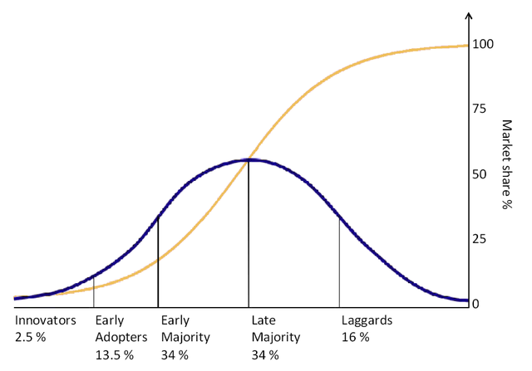

*NOTE*: Image is Copyright OnDigitalMarketing, 2023.

According to Janice Fernandes of YouGov, US adult fashion consumers (256 million) come in four categories:

* Fashion pioneers, with 15% of consumers, are the ultimate fashion enthusiasts and are the most likely to spend big money on new fashions (Fernandes, 2022). This group is also more likely to be young, with 43% in the age 18 to 29 range (Fernandes, 2022).
* Fashion-conscious, with 14% of consumers, still enjoy being up to date on new styles but are more likely to be looking for discounts/sales and are less willing to spend the most money on new fashions (Fernandes, 2022). This group, however, is the largest segment to use social media (Fernandes, 2022). 75% of this group likes to try new brands, and 86% consider themselves well-dressed (Fernandes, 2022).
* Fashion conservatives, with 9% of consumers, still cover 22.2 million US adults, with 31% being between ages 18 and 29 (Fernandes, 2022). This group is twice as likely to buy premium products and more likely to buy luxury items than the general populace (Fernandes, 2022).
* Fashion monotonous, with 62% of consumers, represents the broader population. Fernandes did not analyze this group specifically; however, some statistics are shown in the article: 21% of the general public are between the ages of 18 and 29, 24% of the general public claim to spend a lot on clothing, 31% of the general claim to public dress to stand out, and 17% of the general public spend $200 or more per month (Fernandes, 2022).

Figure 14 shows these groups of consumers in a graphical format based on their YouGov survey responses.

**Figure 14**

*YouGov US adult fashion consumer types.*

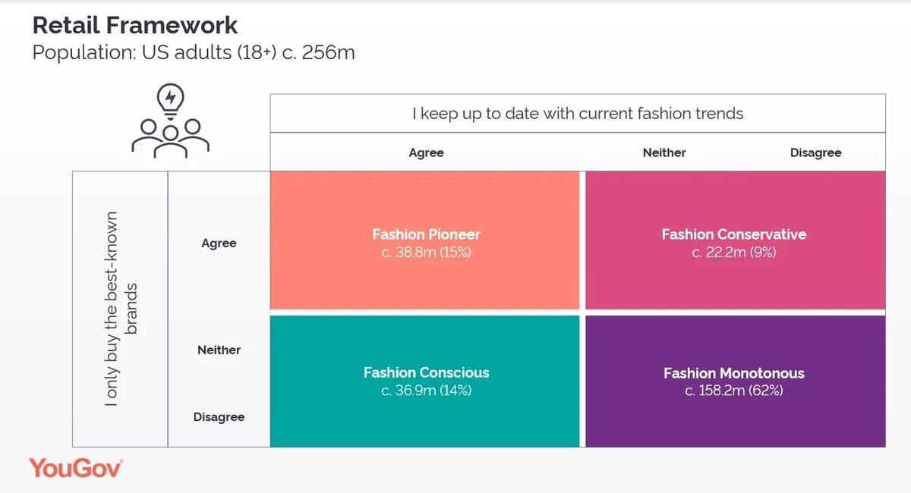

*NOTE*: Image is Copyright Janice Fernandes and YouGov, 2022 (Fernandes, 2022).

***Possible Adoption Timelines***

John Carter of TCGen noted a study done by McKinsey & Co. that showed two outcomes: a product that was six months late into the market earned 33% fewer profits vs. a product that was released on time and 50% over budget, where only 4% fewer profits were observed (Carter, 2024). Carter states, “new market entrants enjoy clear market share, revenue, sales growth, and overall competitive advantage,” so being earlier typically is better to get a first-mover advantage (Carter, 2024). In addition to higher revenues and market share from an earlier entry, R&D costs are also reduced (Carter, 2024). The time to market (TTM) is considered both quantitative and qualitative because the impacts can be measured numerically yet deciding on when to launch is more of an art as it depends on a variety of factors that can be hard to measure, like how consumers might feel about a new product idea or anticipation of what other competitors are doing (Carter, 2024). Figure 15 shows a graph comparing two different curves of TTM, showing the relationship between elapsed time (x-axis) and the revenue/costs (y-axis) (Carter, 2024). Each curve represents a different TTM choice.

**Figure 15**

*Comparison between two different time-to-market choices.*

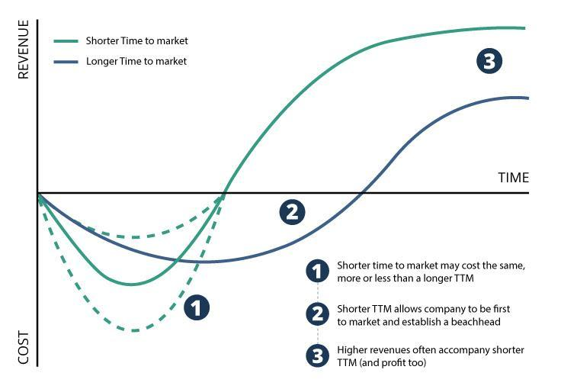

*NOTE*: The image is Copyright John Carter / TCGen (Carter, 2024).

In this image, one can observe that the long TTM curve (in blue) has lower costs per unit of time (evidenced by how deep the curve is) but takes longer to break even and has a lower peak in revenue afterward (Carter, 2024). The shorter TTM curve (in green) shows higher costs per unit of time but a quicker recovery to breaking even and having higher revenue than the longer TTM, even overtaking the blue curve’s peak roughly halfway through the cycle (Carter, 2024). For whatever technology was used in the example, the shorter TTM was the correct option (Carter, 2024). Two possible adoption timelines can be created: launching the hybrid aerohaptics/Virtual Fashion Mirror in 2027 as soon as a minimum viable product (MVP) is ready or waiting longer, possibly until HYPERVSN’s official goal of 2029, to launch a more polished product. The risks of waiting until 2029 involve any of the many competitors listed by DMR’s report that projects out to 2032 (DMR, 2023) launching a similar product and ruining a first-mover advantage HYPERVSN may still have in 2027.

***Ideal Adoption Timeline***

Between the critical choice differences Carter shows in the graph, the differences in categories of people who buy fashion products indicated by Fernandes, and the consumer categories most likely to buy new technologies like this one (innovators, early adopters, and the early majority), it is ideal to concentrate on working with the University of Glasgow and Virtual On Limited to try to get a Virtual Fashion Mirror with aerohaptics out on the market in 2027 with a focus on the innovators and early adopters who also are fashion pioneers and fashion conscious consumers. This will allow HYPERVSN to be part of the virtual mirror market during the second half of the time when DMR projected the global virtual mirror market to reach 72.4 billion USD (DMR, 2023). Figure 16 shows a preliminary timeline that extends into 2029, when a second iteration of the product could be developed.

**Figure 16**

*Preliminary timeline of the product’s development.*

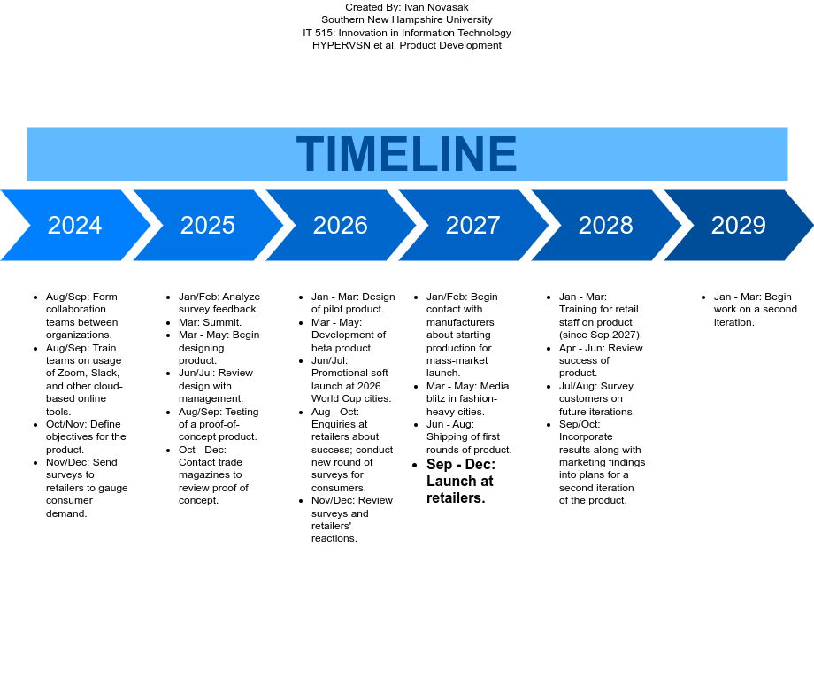

**Variables That May Affect Launch**

In 2016, Roslyn Frenz, writing for *Chron*, indicated four variables that can affect a product’s business cycle. She first states what the product’s business cycle is: the four stages known as introduction, growth, maturity, and then decline (Frenz, 2016). The variables affecting this cycle, including its start for a particular product are finances, marketing, competition, and time (Frenz, 2016).

Finances can significantly vary depending on the phase of a product’s business cycle because sales are usually low at the outset and are combined with high R&D expenses. As the product matures and more people buy it, finances become very profitable. Eventually, as all the people who wanted the product already have it, sales decline causing profits to approach zero again (Frenz, 2016).

Marketing is a category where many funds need to be expended to get exposure to the public; then, eventually, the network effect comes into play as customers tell their friends and family about the new product (Frenz, 2016). Marketing also extends to where the manufacturer will sell the new product and who will ship it (Frenz, 2016). When the product matures, the manufacturer may make enhancements to it then need marketers again to advertise new features to consumers they hope will upgrade (Frenz, 2016).

The competition is the third variable in consideration (Frenz, 2016). If a manufacturer is bringing a product into a category that never existed, they have just created a new market, and other companies will eventually become competitors once the new creation enters the growth stage (Frenz, 2016). On the other hand, if the new product is like others already present, the new entrant will need to compete on what features will differentiate it from competing products that already exist on the market (Frenz, 2016). The aerohaptics/Virtual Fashion Mirror concept for HYPERVSN will put them in a market where they will have several competitors and will expect to have an edge with a virtual mirror displaying holograms customers will be able to touch and feel; so, this is a case of HYPERVSN entering the latter type of market situation.

The final variable is time, as in how long the overall business cycle can last from start to end (Frenz, 2016). Other factors not mentioned by Frenz that can affect when to launch new products or technologies include factors like recessions, a pandemic, and natural disasters in areas where the product was being manufactured. All of these are factors that many people have experienced that made them reconsider or delay purchasing a product and could delay a company from launching a said product, too.

**Implementation Process**

The final section of this document covers the implementation plan and goals, communication, involved stakeholders, ethical and legal compliance, as well as privacy and security concerns for the aerohaptics/Virtual Fashion Mirror hybrid technology.

**Plan**

Due to the wide-ranging locations each involved organization, with HYPERVSN in three different countries, Euclideon in Brisbane, Virtual On in Northampton, and University of Glasgow in Scotland, it is best for any communication that may involve more than one of these organizations to be done online using a virtual tool like Slack, Zoom, or even email. Besides those three tools, according to Melanie Pinola of Zapier, some other essential software tools include screen-sharing software, an online office suite, a cloud storage service, a note-taking app, online backup, and a VPN (Pinola, 2020). Pinola says they at Zapier use Slack for team chat, Zoom for video conferencing, Jira (or Trello or Airtable) for project management, and Google G Suite for the online office suite (Pinola, 2020). For the other categories, she suggests reading reviews to find the one best suited for one’s needs as several good tools exist and it is up to the user on which they prefer (Pinola, 2020). The author of this document has extensive experience using Zoom, Slack, and Google’s ecosystem of tools in his time tutoring mathematics at his workplace as well as when being mentored in Java programming and so the tools Google offers that are relevant - G Suite, Docs, Sheets, and Keep - are recommended for the collaboration HYPERVSN, Euclideon, Virtual On, and the University of Glasgow are doing. The author has had a good experience using both NordVPN and ExpressVPN in the past and has had no problems with either service, so if users at any of the organizations are not already using a VPN, they could start by using one of them, then review business-specific ones if any special features are needed.

***Goals***

The goal is to have the aerohaptics/Virtual Fashion Mirror hybrid product in all interested retailers in 2029, with a pilot launch in 2027 at some retailers and a proof of concept in 2025. Each of the four organizations involved in making this happen plays a role in ensuring this happens.

***Steps Each Organization Can Take***

HYPERVSN will be in charge of coordinating the project as a whole, as they are the organization who is intending to bring this idea to the masses (McConnell, 2024). Euclideon and Virtual On can work together on expanding Virtual On’s Virtual Fashion Mirror to a larger size so that customers in retail stores’ fitting rooms can feel more immersed in the virtual environment when trying virtual clothing on. The University of Glasgow will contribute by adding their aerohaptics technology to the product Euclideon and Virtual On are making. HYPERVSN will review these contributions and suggest any improvements that need to be made. HYPERVSN can use Virtual On’s experience to contribute developments and knowledge in commercialization and marketing of the future product, given they have experience selling their existing Virtual Fashion Mirror product to retailers and other holographic products to other venues (Virtual On, 2024). HYPERVSN will also need to conduct surveys amongst retailers and customers to find out how much demand there could be for this hybrid product.

***Will any other existing processes be affected?***

Virtual On appears to be the organization who will have the most processes affected because they already have existing products up for sale (Virtual On, 2024b). The University of Glasgow will be the least affected due to their primary activity is research, such as with the aerohaptics development. The other two organizations, HYPERVSN and Euclideon, also may not be as disrupted given their holographic products will be used in this hybrid product. As a result, Virtual On may need to hire more product developers, marketers, and sales employees to cater to this new additional product. If this will be their first experience collaborating with another organization, they may need training on the software tools along with being more aware of their roles in this project.

***Communication Among Organizations Regarding Changes - Virtual Teams***

According to Arial Lopez of ProjectManager.com, there are six different types of virtual teams that can be formed (Lopez, 2020). The types of virtual teams that will be most applicable for the collaboration between HYPERVSN, Eucideon, Virtual On, and the University of Glasgow are networked, product development, service, and management (Lopez, 2020). The sales and marketing team will be an example of a service team because they are scattered in different time zones but do the same work so that customers will always have someone to communicate with when they are looking to buy one of the products (Lopez, 2020). R&D will be one of the networked teams because while they will be from different organizations, they will all have the hybrid aerohaptics/Virtual Fashion Mirror as the common goal to work on (Lopez, 2020). The product development team will work independently but will need to communicate with the project managers and R&D to ensure the product is within engineering specifications and tailored to the expectations of retailers who will be deploying it (Lopez, 2020).

According to Elizabeth Perry of BetterUp, an effective virtual team has high levels of trust, communication, and knowledge-sharing (Perry, 2021). Navigating the world of virtual work needs people who are resilient, empathetic, and culturally sensitive, as well as having high emotional intelligence, a solid ability to work autonomously, and strong communication skills (Perry, 2021). It is optimal to keep the virtual teams small, perhaps around three to five members per team as smaller teams are more efficient than larger teams (Perry, 2021). To assess who will be the best fit for each team, conducting surveys, behavioral interviews, and personality testing in addition to training is a good strategy for forming the team (Perry, 2021). Everyone on each team should have clearly defined roles and responsibilities and should know each other’s roles on the team (Perry, 2021). Setting specific goals for the overall team and each member is essential to ensure the virtual team effectively uses their time and each member feels they have positively contributed to and have ownership in the project (Perry, 2021). If the team must be a huge team, dividing that team into smaller sub-teams catering to each business objective is the ideal way to go (Perry, 2021). For instance, there could be a team for R&D, another team for marketing, yet another for handling surveys and consumer responses, and finally a team for managing the overall project’s timeline. It is good practice to do a weekly check-in with the team via Zoom or another video conferencing software to ensure the team is running smoothly and everyone is communicating well with each other (Perry, 2021). Since there will be multiple teams for this project, there could be alternate weekly meetings that concern each aspect of the project as well as larger, monthly meetings for the collaboration as a whole to discuss how the overall progress is going in relation to the timeline. Slack, Discord, or another instant messaging service is essential to virtual teams due to the asymmetric nature of virtual work (Perry, 2021). Project management software, like Microsoft Project, can keep the team’s communications and work tasks in sync across the entire team and allow management to easily view the project’s progress (Perry, 2021).

Given the global reach of this collaboration, time zones are another aspect of virtual work that has to be taken into account to ensure everyone can easily contribute, including meeting attendance. TimeandDate.com has a meeting planner where a user can enter the cities the participants are in and then get a listing of times that are the most meeting-friendly across most places (TimeandDate.com, n.d.). This can help people find an ideal meeting time for participants scattered in different time zones. Most of the organizations’ headquarters in this collaboration are in European time zones, so meeting times that are ideal for them should be prioritized, though there may be a time of day ideal for all four organizations. According to (TimeandDate.com n.d.), their Meeting Planner indicates that 07:00 UTC (08:00 British Summer Time/BST, 10:00 Minsk time, 17:00 Brisbane time) is the ideal hour for a meeting as this hour is during the traditional workday during daylight hours. If Euclideon, in Brisbane, is willing to extend into the evening (their time zone), the next several hours up to 11:00 UTC / 12:00 noon BST / 14:00 Minsk / 21:00 Brisbane; this could mean up to four hours could be used where all four organizations can collaborate in synchronization. During the virtual meetings, everyone should be able to contribute at least one new thing to the group for future reference and suggestions. Meetings should not run too long (especially if a later start time is chosen where it will be nighttime where Euclideon is based), which can drain people’s attention; a suggestion is to keep weekly check-in meetings to a maximum of two hours. Now that the ideal time of day is ascertained, a survey should be taken to find the ideal day(s) of the week for regular meetings.

Language is another area that can be confusing for virtual teams with members in different countries. It is best to use plain language with no slang or cultural idioms. Explain any technical words, jargon, or words that are used a lot at the organization that are unique to specific cultures and may be unfamiliar to people on the team who are working elsewhere. According to Melissa Lamson of LinkedIn, in “a 2012 Society for Human Resource Management survey,” the most common challenges with global virtual teams were time zone differences, work distribution, cultural norm differences, and technology issues (Lamson, 2015). It is good to establish trust in each other in the team by having exercises where people, if they feel comfortable, can disclose their hopes and dreams, their family life, recreation, as well as fears or concerns (Lamson, 2015). Sharing leadership responsibilities within a project that is valuable to the organization can also build trust in that the employees can see how each other contributed positively to the goal of the project and organization (Lamson, 2015). It is essential to be aware of different communication styles and cultural conventions and note that what is considered normal in one culture may be considered strange, uncomfortable, or even disrespectful (Lamson, 2015). Some prefer phone or video chat, while others prefer written communication (Lamson, 2015). This can also be a cultural difference in that some cultures may require one specific or both forms of communication for something to be official (Lamson, 2015). A cultural liaison who is familiar with working in different countries can work wonders if one is making a virtual team that is globally scattered. It is also good to discuss how each member of the virtual team will be contributing and has contributed to the success of the organization; remote employees can often get “lost in the shuffle” (that is, quickly forgotten by on-site staff), and so their contributions need to be more explicit (Lamson, 2015).

**Stakeholders**

In the Affected Stakeholders section of this document, several stakeholders for the aerohaptics/Virtual Fashion Mirror hybrid were identified from each organization. They are once again stated here, along with some others, in Table 2 below.

**Table 2**

*Organizations and their stakeholders.*

|  |  |
| --- | --- |
| **Organization** | **Stakeholders** |
| University of Glasgow | Ravinder Dahiya (primary developer of the aerohaptics technology) / R&D and equipment suppliers |
| Virtual On, Ltd. | Product developers, marketers, sales employees, and equipment suppliers |
| HYPERVSN | Project managers and survey/feedback staff |
| Euclideon | Engineering/R&D |
| The retailers | Store managers and investors |
| The consumers | Viewers and wearers of the clothing they buy |

***Potential Stakeholder Needs***

HYPERVSN is the first company with stakeholders, as they are the company who identified the need for a hologram that can be touched without the need for the user to wear any extra equipment (McConnell, 2024). The project managers who will oversee the development of the product and the survey/feedback staff who will write surveys for Virtual On and retailers are internal stakeholders. HYPERVSN is outsourcing the engineering of the hologram to Euclideon (McConnell, 2024) and bringing on Virtual On and the University of Glasgow as further developers to bring this idea to life.

The engineers and R&D departments of each of these organizations are stakeholders in that they will ascertain how feasible the idea is and whether the identified timeline is realistic. Equipment suppliers are more of a minor stakeholder but have some stake as they will sell more of their components should this product succeed.

The marketers, sales staff, and retailers have a bigger stake in this project because they will be who consumers will likely be exposed to between surveys and the product’s presence in stores once it is developed. They will need to be notified of ways they can contribute to the product, including what kinds of preparation retailers will need to do at their storefronts and how their customers will be assured any data the product collects and processes will not fall into malicious actors’ possession. Should the aerohaptics/Virtual Fashion Mirror hybrid be successful, retailers will have more business coming their way and could look into expansion of their stores and their investors will have more profits coming their way.

Consumers will be the people who benefit the most from this product as it will show them a new advantage of shopping in-person after experiencing many drawbacks of online clothing shopping due to poorly fitting clothing and lack of seeing how the clothing will look on them.

***Ensuring Potential Needs Are Met***

Zoom and Slack are the primary communication tools that will be used to collaborate. Online checklists and reminders like what Google offer to individuals in Google Keep and Calendar are helpful to keep people on task throughout each week and month. The online checklists in Slack are essential so all collaborators know what has been completed and which tasks are yet to be finished (Slack, n.d.). The most common problems virtual teams encounter are technology issues, miscommunication, lack of effective collaboration, no easy way for team members to get to know each other, and lack of serendipitous ideas that, in an in-person environment, might come up employees are not doing anything specific, such as when in the break room (Perry, 2021). Some of this can be fixed by having events, meetups, and summits regularly, such as the ones BetterUp does for team building twice every year (Perry, 2021). It is a challenge to meet regularly for the four organizations that are developing this product, but it would be valuable to have at least two summits per year so people can meet in person and discuss the project and be more excited about the innovations they are bringing to the world. There should be at least a summit before the pilot launch in 2027 and another before the general retail launch in 2029. Perhaps these could be coordinated with a large technology or fashion event during those years.

**Ethical Compliance**

Protection of users’ data is vital to any business, and so there are different laws and relevant ethics policies that are relevant. Some ethical practices are not specific laws but are just good practice.

***Relevant Ethics Guidelines, Laws, and/or Codes***

According to Yifat Perry, a technical content manager at NetApp, Inc., several relevant data security and privacy laws from around the world include, but are not limited to (Perry, 2019):

* The General Data Protection Regulation (GDPR) for the European Union
* California Consumer Privacy Act (CCPA)
* Personal Information Protection and Electronic Documents (PIPEDA) for Canada
* The Brazilian General Data Protection Act (LGPD)
* The Australian Consumer Data Right (CDR)
* The Protection of Personal Information Act (POPI) of South Africa.

In summary, these laws require that residents or citizens of the applicable countries know why a specific piece of data is being collected, are ensured that any data collected are protected from unauthorized gathering, the right to have their data erased, the right to be notified if a data breach happened that endangers their freedoms and rights (Perry, 2019). The data collected that are affected by these regulations include any that organizations collect and can identify a person; it can range from names, street addresses, telephone numbers, Social Security numbers, national identification numbers, internet activities, biometric sensor readings, and Internet-of-things devices (Perry, 2019). The fines for violating these laws can be high and range from $50,000 USD per incident for HIPAA violations to “€20 million or 4% of worldwide annual turnover” and the “right of Data Protection Authorities to prevent a company from collecting or processing personal data while a suspected non-compliance or breach is being investigated” both for GDPR data breaches (Perry, 2019).

According to Cassie at Syrenis Ltd., consent and transparency are the hallmarks of ethical data handling (Cassie, 2023). Transparency is crucial to establishing trust in a business, so customers need to be explicitly told why any data they are required to enter is needed and precisely for which purposes to be used for. In addition, customers need to be aware that they have the freedom to ask that any information on them be deleted with no questions asked (Cassie, 2023). They need to be confident that any data collected will be protected from malicious parties and breaches (Cassie, 2023). According to MoldStud, it is important to handle data ethically because without doing so, one runs the risk of data breaches. Data breaches can result in financial losses and reputation damage, privacy violations that can cause loss in customer trust and have legal consequences, unauthorized data usage such as selling of data, and unfair or inaccurate decisions or biased algorithms made based on insufficient and inaccurate data (MoldStud, 2024). The financial losses and reputational damage alone can be severe enough to put a company out of business.

Data minimization is an aspect of ethical data handling that is when only the data or information needed to conduct business shall be collected (Cassie, 2023). For instance, the Virtual Fashion Mirror needs to take a photo of the customer and may need the customer’s height and weight to better ascertain the clothing size and display how it will look on the customer, but not the person’s ethnicity, so ethnicity shall not be asked for or obtained. Privacy by design is the practice of integrating privacy into all processes, products, business practices, and services on offer (Cassie, 2023). Training of all employees about privacy laws and practices is vital to ensure that no laws are broken, and customers are aware that not only the retailer but the privacy practices in effect have legal backing (Cassie, 2023). Another essential aspect of ethical data handling that contributes to privacy is data anonymization (MoldStud, 2024). Anonymization is the process of removing personally identifiable information from elements that are used in aggregate reports (MoldStud, 2024). It is recommended to have a policy on how long data is retained and for users to know how long their data will be kept before it is discarded (MoldStud, 2024). Users' data can be protected by encryption, access controls, and security audits, ensuring the data are safe and not able to leak to unauthorized and malicious parties (MoldStud, 2024).

Privacy and ethics also extend to the physical world, and so a recommendation is to treat the hybrid aerohaptics/Virtual Fashion Mirror device as an addition to standard fitting rooms in stores, so only one person should be allowed inside as is standard in traditional fitting rooms.

**Legal Compliance**

The previous subsection of this document, Relevant Ethics Guidelines, Laws, and/or Codes, described the relevant laws and ethics codes one should follow for managing data in a business that deals with the public. This section describes the model used to comply with those laws.

***Ensuring a Smooth and Compliant Transition via an Information Assurance Model***

According to GeeksforGeeks, a cyber security information assurance model is the implementation of a method that ensures data is kept confidential, has integrity, is available, and has non-repudiation (GeeksforGeeks, 2021). Confidentiality is when the data collected is kept secret and protected against access by anyone who is not authorized, either by malicious means or accidental release (GeeksforGeeks, 2021). Integrity is the fact that the collected data is accurate and can be trusted (GeeksforGeeks, 2021). It requires that data cannot be altered, created, or deleted without being authorized (GeeksforGeeks, 2021). Another part of integrity is performing backups for any data that is expected to be kept long-term, like financial data (GeeksforGeeks, 2021). Using cryptographic checksums can be used to ensure any data was not modified in transmission (GeeksforGeeks, 2021). Availability is the ability for data to be accessed by authorized users even if a component in the system fails (GeeksforGeeks, 2021). Two examples of availability are having backup power generators to keep systems running in a power outage, and RAID-1 hard disk mirroring, which Alexander S. Gillis, Erin Sullivan, and Brien Posey of TechTarget mention about which clones a single hard disk’s contents in real time, as data is being written, so that in case if a hard drive fails the other drive will have the same data (Gillies et al., 2021).

Authentication is verifying the person using the system is who they claim to be (GeeksforGeeks, 2021). According to Kinza Yasar and Mary E. Shacklett of TechTarget, multi-factor authentication is becoming a popular method, which involves not only a username and password but also the user being sent a one-time code to their phone or presenting a security card or using their fingerprint (biometrics) (Yasar & Shacklett, 2023). The three factors are broken down as (Yasar & Shacklett, 2023):

1. Something you have (device/card/another object).
2. Something you know (username, password, account number).
3. Something you are (fingerprint, eye scan, or face scan).

Non-repudiation is the final aspect of information assurance, which is a mechanism that ensures the recipient of a piece of data cannot deny that they received it (GeeksforGeeks, 2021). The transmission of data will include who sent it and when, who received it and when, and an acknowledgement that the data was opened by the recipient (GeeksforGeeks, 2021).

The information assurance model is multidimensional and contains four dimensions, which are as follows (GeeksforGeeks, 2021):

* Information states, which are any of three possibilities for the information: stored, processed, or transmitted.
* Security services, which are the “availability, integrity, confidentiality, authentication, and non-repudiation” that were mentioned above.
* Security countermeasures, which are the combination of people employed to maintain the system, written security policies that are enforced by said people, encryption of data, and physical devices that are designed with the express intent to keep out unauthorized people from the system. These devices may include firewalls, intrusion-detection hardware, routers, security alarms, and even locked doors or safes that kick in when a security breach may be attempted.
* Time is the dimension that covers all of the others and is when a piece of information can be in any state at a given time, as well as changing states and may be secure or vulnerable.

Figure 17 shows these dimensions together in a cube, with time shown alongside the cube as an arrow.

**Figure 17**

*The information assurance model’s dimensions.*

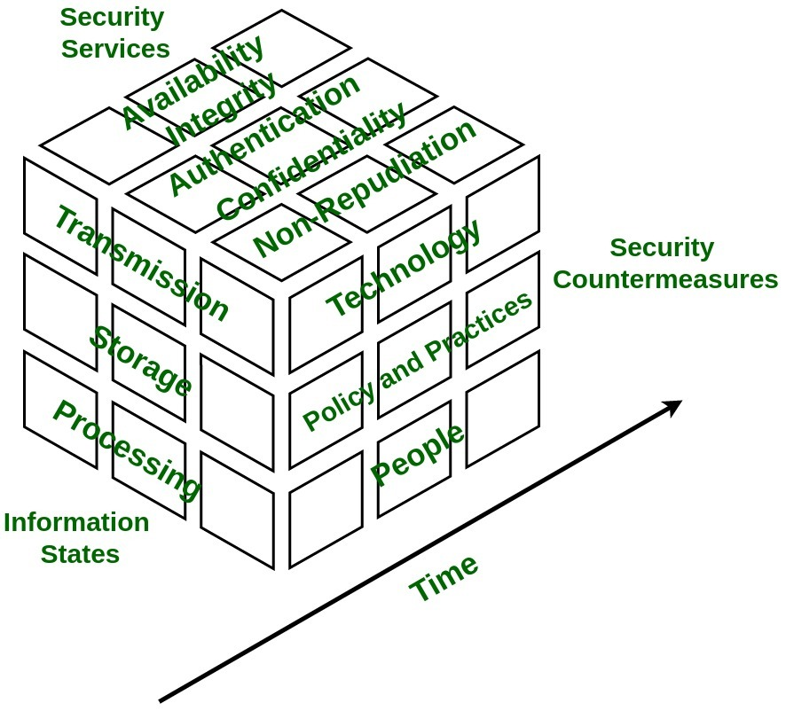

*NOTE*: This image is Copyright GeeksforGeeks 2021.

**Addressing Technological Security Concerns**

According to Lithos Technosoft Pvt Ltd, writing on LinkedIn’s website, several threats exist that can compromise security of business data both within the HYPERVSN et al. collaboration and any data retailers will need and use in the deployment of the hybrid product (Lithos Technosoft Pvt Ltd, 2024):

* Data breaches - when data is stolen by someone who is not authorized to access it.
* Phishing attacks - the use of deception to make users believe they are accessing a genuine website but instead is fake and used to capture user credentials such as with fake login screen that looks legitimate.
* Malware - computer viruses, trojan hoses, spyware, and other harmful software that criminals install onto computers that can “steal data, disrupt operations, or damage systems.”
* Ransomware - the practice of cyber criminals hacking into a computer system and encrypting important data then claiming to the owners to pay a ransom to get their data back.

Having strong multi-factor authentication in the business computers is essential, as such an authentication system requires at least two methods of identification before a user can gain access to the system (Lithos Technosoft Pvt Ltd, 2024). If one element is compromised, say the password, the person attempting to log in will still not be able to access the system because they will not have the other element(s) needed for entry (Lithos Technosoft Pvt Ltd, 2024). Security patches and updates are essential, so the computers have vulnerabilities closed as quickly as possible (Lithos Technosoft Pvt Ltd, 2024). This includes updates to all user programs, the operating system, and anti-virus software (Lithos Technosoft Pvt Ltd, 2024). This includes mobile devices like phones and tablets, too (Lithos Technosoft Pvt Ltd, 2024). Due to the wide variety of devices on the market running different operating systems, the exact procedure for keeping individual devices up to date will need review of the settings, instructions, or advice from the IT team or software vendor.

Another strategy is encryption of any data to be transmitted (Lithos Technosoft Pvt Ltd, 2024). For web access, ensure that any website benign accessed on a business computer is using the HTTP**S** protocol and not regular HTTP (Lithos Technosoft Pvt Ltd, 2024). The S means Secure and will have data that is both transmitted to and from encrypted so that hackers will not be able to access it (Lithos Technosoft Pvt Ltd, 2024). Another form of encryption that is useful is on-device encryption for physical devices so that even if a device is stolen, its contents cannot be read without a decryption key (Lithos Technosoft Pvt Ltd, 2024).

These security threats are another reason to regularly conduct full backups so that one has access to their data prior to it being compromised in case the system remains inaccessible following an attack that got through (Lithos Technosoft Pvt Ltd, 2024).

***Protection of Personal and Business Data***

According to Nick Barney and Ben Lutkevich of TechTarget, network security is another area of concern for data security (Barney & Lutkevich, 2022). This concerns the way computer systems are connected to each other and the Internet at large (Barney & Lutkevich, 2022). In addition to multi-factor authentication, encryption, updating of software, and training of users mentioned above, network devices such as a firewall, intrusion detection, and routers are essential for securing data that flows along a network (Barney & Lutkevich, 2022). Routers serve the purpose of separating networks inside a building such that different computers and users’ roles are on different networks (Barney & Lutkevich, 2022). It is generally good practice to keep servers that store confidential data on separate networks from day-to-day customer service systems by using routers (Barney & Lutkevich, 2022). Firewalls are both hardware and software components that scan and block malicious traffic by analyzing data packets that are entering and leaving the network entirely (Barney & Lutkevich, 2022). They may also block certain ports that are insecure or unused on the network that cyber criminals can take advantage of to gain access (Barney & Lutkevich, 2022). Intrusion detection systems, if used, work in conjunction with firewalls and detects unauthorized attempts at accessing the network or potential malicious traffic but does not block the traffic entirely (Barney & Lutkevich, 2022). They alert the network administrator that the traffic may be a danger to the network (Barney & Lutkevich, 2022). Figure 18 shows the network hardware setup in action. Zero-trust is a network design that grants users only the specific permissions they are required to have in their role in the network and not more (Barney & Lutkevich, 2022).

**Figure 18**

*Network hardware device connections*

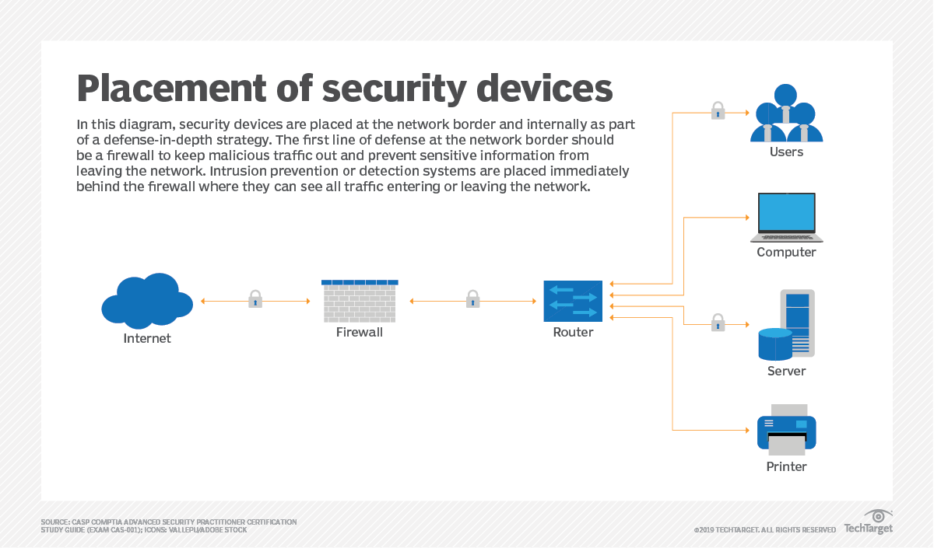

*NOTE*: This image is copyright Nick Barney, Ben Lutkevich, TechTarget 2019.

# References

3DLOOK. (2024a, January 17). *Our technology*. 3DLOOK INC. <https://3dlook.ai/technology/>

3DLOOK. (2024b, April 5). *Pricing*. 3DLOOK INC. <https://3dlook.ai/pricing/>

3DLOOK. (2024c, April 10). *Mobile Tailor - AI-Powered Body Measuring Solution*. 3DLOOK INC. <https://3dlook.ai/mobile-tailor/>

3DLOOK. (2024d, May 22). *Contact us*. 3DLOOK INC. <https://3dlook.ai/contact-us/>

Barney, N., & Lutkevich, B. (2022, October 5). *network security*. TechTarget. <https://www.techtarget.com/searchnetworking/definition/network-security>

Bhasin, H. (2019, April 17). *What is Technology Life Cycle? 4 Stages of Technology Life Cycle*. Marketing91. <https://www.marketing91.com/technology-life-cycle/>

Carter, J. (2024, March 21). *Time To Market (TTM): What it is & Why It’s Important*. TCGen Inc. <https://www.tcgen.com/time-to-market/>

Cassie. (2023, December 29). *A guide to navigating US privacy laws for retailers*. Syrenis Ltd. <https://trustcassie.com/resources/blog/navigating-us-privacy-laws-for-retailers/>

Christou, A., Chirila, R., & Dahiya, R. (2022). *Pseudo-Hologram with Aerohaptic Feedback for Interactive Volumetric Displays*. Adv. Intell. Syst., 4: 2100090. <https://doi.org/10.1002/aisy.202100090>

Dahiya, R. (2021, September 17). *We created holograms you can touch – you could soon shake a virtual colleague’s hand*. The Conversation. <https://theconversation.com/we-created-holograms-you-can-touch-you-could-soon-shake-a-virtual-colleagues-hand-167478>

Dimension Market Research. (2023, November). *Virtual Mirror Market By Component (Software, Hardware, Services), By Deployment, By Technology, By Industry - Global Industry Outlook, Key Companies (Cisco System, ViuBox, SenseMi and others), Trends and Forecast 2023-2032*. Dimension Market Research. <https://dimensionmarketresearch.com/report/virtual-mirror-market/>

Fernandes, J. (2022, January 24). *YouGov Framework – fashion retail in the US*. YouGov PLC. <https://today.yougov.com/consumer/articles/40574-yougov-framework-fashion-retail-us-survey>

Frenz, R. (2016, October 26). ‘Four variables that affect the business cycle’..’ *Chron.com*. Hearst Newspapers. <https://smallbusiness.chron.com/s-curve-business-23032.html>

GeeksforGeeks. (2021, October 29). *Information Assurance model in Cyber security*. GeeksforGeeks. [https://www.geeksforgeeks.org/information-assurance-model-in-cyber-security/#](https://www.geeksforgeeks.org/information-assurance-model-in-cyber-security/)

Gillis, A. S., Sullivan, E., & Posey, B. (2021, August 18). *RAID (redundant array of independent disks)*. TechTarget. <https://www.techtarget.com/searchstorage/definition/RAID>

Google. (n.d.). *Use Voice Access commands - Android Accessibility Help*. Google. <https://support.google.com/accessibility/android/answer/6151854?sjid=16209531169736031871-NA>

Lamson, M. (2015, October 25). *Three Ways to Overcome Barriers in Virtual, Dispersed Teams*. LinkedIn. <https://www.linkedin.com/pulse/three-ways-overcome-barriers-virtual-dispersed-teams-melissa-lamson/>

Lithos Technosoft Pvt Ltd. (2024, January 29). *Comprehensive Guide to Data Privacy and Protection for Retailers*. LinkedIn. <https://www.linkedin.com/pulse/comprehensive-guide-data-privacy-protection-retailers-q4q8c/>

Lopez, A. (2020, July 23). *What is a virtual team? Definition & examples*. ProjectManager.com, Inc. <https://www.projectmanager.com/blog/what-is-a-virtual-team>

McConnell, W. (2024). *Final Project Guidelines and Rubric - IT-515-Q4535 Innovation in Info Technology 24TW4*. Southern New Hampshire University. <https://learn.snhu.edu/d2l/le/content/1567992/viewContent/32260614/View>

MoldStud. (2024, February 1). *Database development and Ethical data handling Practices.* MoldStud. <https://moldstud.com/articles/p-database-development-and-ethical-data-handling-practices>

OnDigitalMarketing. (2023, May 2). *The 5 Customer Segments of Technology Adoption*. On Digital Marketing. <https://ondigitalmarketing.com/learn/odm/foundations/5-customer-segments-technology-adoption/>

Perry, E. (2021, May 18). *The Success behind Virtual Teams: The Ultimate Guide*. BetterUp. <https://www.betterup.com/blog/virtual-teams>

Perry, Y. (2019, September 17). *Meeting Data Compliance with a Wave of New Privacy Regulations: GDPR, CCPA, PIPEDA, POPI, LGPD, HIPAA, PCI-DSS, and More*. NetApp, Inc. <https://bluexp.netapp.com/blog/data-compliance-regulations-hipaa-gdpr-and-pci-dss>

Pinola, M. (2020, April 10). *The remote worker’s toolkit: The 15 tools you need to work remotely*. Zapier, Inc. <https://zapier.com/blog/productivity-apps-remote-work/>

RedThread. (n.d.). *Scan trial*. RedThread. <https://redthreadcollection.com/pages/scan-trial>

Slack. (n.d.). *Slack lists | Project management in Slack* [Video]. Slack. <https://slack.com/intl/en-gb/features/task-list>

Statista. (2023, August 31). *Smartphone (consumer/enterprise) average price in the United States 2013-2027*. <https://www.statista.com/statistics/619830/smartphone-average-price-in-the-us/>

Statista. (2024, February 13). *PCs: global ASP forecast 2015-2019*. <https://www.statista.com/statistics/722992/worldwide-personal-computers-average-selling-price/>

TimeandDate.com (n.d.). *International Meeting Planner*. Time and Date AS. <https://www.timeanddate.com/worldclock/meeting.html>

Virtual On. (2024a, January 31). *Interactive Fashion Mirror | Virtual Fitting or Dressing roomRoom*. VIRTUAL ON LTD. <https://virtualongroup.com/interactive-fashion-mirror-virtual-fitting-dressing-room/>

Virtual On. (2024b, April 21). *Rent & Sale - Virtual on - online Budget calculator*. VIRTUAL ON LTD. <https://virtualongroup.com/rent-and-sale/>

Virtual On. (n.d.). *factsheet: Virtual Fashion Mirror*. VIRTUAL ON LTD. <https://virtualongroup.com/wp-content/uploads/2024/01/Virtual-Fitting-Mirror.pdf>

Yasar, K., & Shacklett, M. E. (2023, October 2). *multifactor authentication*. TechTarget. <https://www.techtarget.com/searchsecurity/definition/multifactor-authentication-MFA>